Reformation Day
10:00
October 31, 2021
Zion Lutheran Church Camas, Washington
Ministers: the entire congregation
Susan Dollinger Associate Pastor
Pam Ensley, Youth Minister
Karen Rezabek, Praise Team
Patricia Hagensen, Administrative Assistant
Church office 834-4201, email info@zionluthcamas.org
Hours: Mon 8-12:00, Tues-Fri 8-5:00
“As a welcoming Body of Christ, we celebrate and share God’s saving grace for all.”

INTRODUCTION
Rooted in the past and growing into the future, the church must always be reformed in order to live out the love of Christ in an ever-changing world. We celebrate the good news of God’s grace, that Jesus Christ sets us free every day to do this life-transforming work. Trusting in the freedom given to us in baptism, we pray for the church, that Christians will unite more fully in worship and mission.

Prelude “A Mighty Fortress”
Patrick Murphy, piano; Gary Ritter, organ
Welcome – Announcements
Stand – if standing is difficult please feel free to remain seated
Confession and Forgiveness
P: In the name of the Father, and of the ☩ Son, and of the Holy Spirit.
Amen.
P: Almighty God, to whom all hearts are open, all desires known, and
from whom no secrets are hid: Cleanse the thoughts of our hearts
by the inspiration of your Holy Spirit, that we may perfectly love
you and worthily magnify your holy name, through Jesus Christ our
Lord. Amen.
Silence is kept for reflection
P: Most merciful God,
C: we confess that we are in bondage to sin and cannot free
ourselves. We have sinned against you in thought, word, and
deed, by what we have done and by what we have left undone.
We have not loved you with our whole heart; we have not loved
our neighbors as ourselves. For the sake of your Son, Jesus Christ,
have mercy on us. Forgive us, renew us, and lead us, so that we
may delight in your will and walk in your ways, to the glory of
your holy name. Amen.
P: Almighty God, in his mercy, has given his Son to die for us and, for
his sake, forgives us all our sins. As a called and ordained minister
of the Church of Christ, and by his authority I therefore declare to
you the entire forgiveness of all your sins, in the name of the
Father, and of the ☩ Son, and of the Holy Spirit. Amen.
Stand
Opening Hymn “Praise to the Lord, the Almighty" Number 858
1. Praise to the Lord, the Almighty, the King of creation! O my soul,
praise him, for he is your health and salvation! Let all who hear
now to his temple draw near, joining in glad adoration!
2. Praise to the Lord, who o’er all things is wondrously reigning and,
as on wings of an eagle, uplifting, sustaining. Have you not seen all
that is needful has been sent by his gracious ordaining?
3. Praise to the Lord, who will prosper your work and defend you;
surely his goodness and mercy shall daily attend you. Ponder anew
what the Almighty can do if with his love he befriend you.
4. Praise to the Lord! Oh, let all that is in me adore him! All that has life and brea
come now with praises before him! Let the amen sound from his
people again. Gladly forever adore him!
Setting 10 – Greeting and Kyrie Page 203
P: The grace of our Lord Jesus Christ, the love of God, and the
communion of the Holy Spirit be with you all. And also with you.

-2-

Hymn of Praise Page 204

P: Let us pray. The Lord be with you.
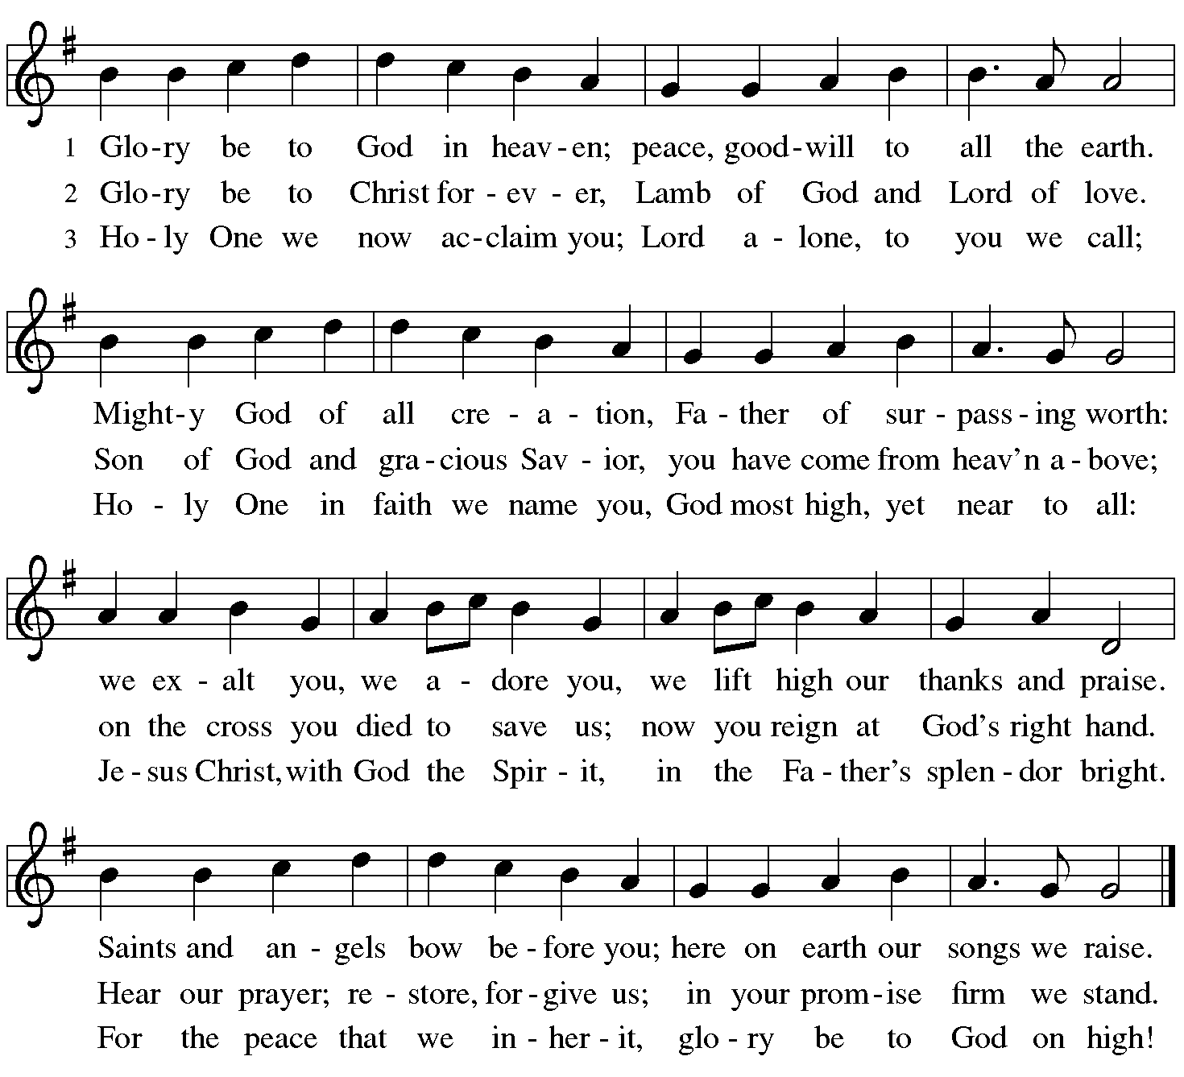
C: And also with you.

Prayer of the Day Luther’s Morning Prayer
P: “I give thanks to You, my Heavenly Father, through Jesus Christ
Your dear Son,
C: that You have protected me this night from all harm and danger
and I ask that You would also protect me this day from sin and
every evil, that all my doings and life may please You. Into Your
hands I commend myself: my body, my soul, and all that is mine.
Let Your Holy Angel be with me so that the wicked foe may have
no power over me. Amen.”
Sit

Bible Reading Jeremiah 31:31-34
The days are surely coming, says the Lord, when I will make a new covenant with the house of Israel and the house of Judah. ³²It will not be like the covenant that I made with their ancestors when I took them by the hand to bring them out of the land of Egypt—a covenant that they broke, though I was their husband, says the Lord. ³³But this is the covenant that I will make with the house of Israel after those days, says the Lord: I will put my law within them, and I will write it on their hearts; and I will be their God, and they shall be my people. ³⁴No longer shall they teach one another, or say to each other, “Know the Lord,” for they shall all know me, from the least of them to the greatest, says the Lord; for I will forgive their iniquity, and remember their sin no more.

L: Word of God, word of life.
C: Thanks be to God.

Responsive Reading Psalm 46
L: God is our refuge and strength, a very present help in trouble.
C: Therefore we will not fear, though the earth should change,
though the mountains shake in the heart of the sea;
L: though its waters roar and foam, though the mountains
tremble with its tumult.
C: There is a river whose streams make glad the city of God, the holy
habitation of the Most High.
L: God is in the midst of the city; it shall not be moved; God shall help
it when the morning dawns.
C: The nations are in an uproar, the kingdoms totter; he utters his
voice, the earth melts.
L: The Lord of hosts is with us; the God of Jacob is our refuge.
-4-
C: Come, behold the works of the Lord; see what desolations he has
brought upon the earth;
L: He makes wars cease to the end of the earth; he breaks the bow,
and shatters the spear; he burns the shields with fire.
C: “Be still, and know that I am God! I am exalted among the
nations; I am exalted in the earth.”
L: The Lord of hosts is with us;
C: the God of Jacob is our refuge.

Bible Reading Romans 3:19-28
Now we know that whatever the law says, it speaks to those who are under the law, so that every mouth may be silenced, and the whole world may be held accountable to God. ²⁰For “no human being will be justified in his sight” by deeds prescribed by the law, for through the law comes the knowledge of sin. ²¹But now, apart from law, the righteousness of God has been disclosed, and is attested by the law and the prophets, ²²the righteousness of God through faith in Jesus Christ for all who believe. For there is no distinction, ²³since all have sinned and fall short of the glory of God; ²⁴they are now justified by his grace as a gift, through the redemption that is in Christ Jesus, ²⁵whom God put forward as a sacrifice of atonement by his blood, effective through faith. He did this to show his righteousness, because in his divine forbearance he had passed over the sins previously committed; ²⁶it was to prove at the present time that he himself is righteous and that he justifies the one who has faith in Jesus. ²⁷Then what becomes of boasting? It is excluded. By what law? By that of works? No, but by the law of faith. ²⁸For we hold that a person is justified by faith apart from works prescribed by the law.

L: Word of God, word of life.
C: Thanks be to God.
Stand
Gospel Acclamation Page 205

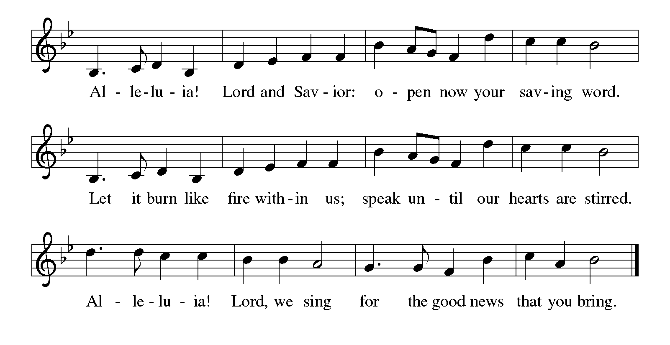

P: The Holy Gospel according to St. John, the eighth chapter.
C: Glory to you, O Lord.

Gospel Reading John 8:31-36
Jesus said to the Jews who had believed in him, “If you continue in my word, you are truly my disciples; ³²and you will know the truth, and the truth will make you free.” ³³They answered him, “We are descendants of Abraham and have never been slaves to anyone. What do you mean by saying, ‘You will be made free’?” ³⁴Jesus answered them, “Very truly, I tell you, everyone who commits sin is a slave to sin. ³⁵The slave does not have a permanent place in the household; the son has a place there forever. ³⁶So if the Son makes you free, you will be free indeed.”

P: The Gospel of the Lord.
C: Praise to you, O Christ!
Sit

Children’s Message Pam Ensley
Message Pr. Susan Dollinger
Stand
Hymn of the Day “We Walk by Faith” Number 635
1 We walk by faith and not by sight; with gracious words draw near,
O Christ, who spoke as none e'er spoke: "My peace be with you
here."
2 We may not touch your hands and side, nor follow where you trod;
but in your promise we rejoice, and cry, "My Lord and God!"
3 Help then, O Lord, our unbelief; and may our faith abound
to call on you when you are near and seek where you are found:
-6-
4 For you, O resurrected Lord, are found in means divine:
beneath the water and the word, beneath the bread and wine.
Apostles’ Creed
I believe in God, the Father almighty, creator of heaven and earth.
I believe in Jesus Christ, God’s only Son, our Lord, who was
conceived by the Holy Spirit, born of the virgin Mary, suffered
under Pontius Pilate, was crucified, died, and was buried; he
descended to the dead. On the third day he rose again; he
ascended into heaven, he is seated at the right hand of the Father,
and he will come to judge the living and the dead.
I believe in the Holy Spirit, the holy catholic church, the
communion of saints, the forgiveness of sins, the resurrection of
the body, and the life everlasting. Amen.
Prayers
Set free from sin and death and nourished by the word of truth, we join
in prayer for all of God’s creation.
A brief silence
We pray for all who long for a word of truth and for the radical grace
that flows from the cross. Inspire congregations to freely and boldly
proclaim your love for all people with persistence and hope. Hear us, O
God.
C: Your mercy is great.
We pray for your creation, for mountains, rivers, streams, cities,
homesteads, and neighborhoods. Write in our hearts a new love and
care for creation. Give us the will to curb wasteful habits. Hear us, O
God.
C: Your mercy is great.
We pray for all who long for healing in mind, body, or spirit, especially
those we remember aloud or in our hearts. Strengthen hospitals,
clinics, counseling centers, nursing homes, and recovery centers to be
holy spaces of renewal that all might live the abundant life you intend.
Hear us, O God.
C: Your mercy is great.

We pray for all who seek to grow in faith and love of you. Guide
teaching and learning in confirmation, small groups, Sunday school,
youth groups, schools, seminaries, and universities. Hear us, O God.
C: Your mercy is great.
We give thanks for all the saints and reformers who have gone before
us who dwell in your holy habitation. Give us courage through their
example to challenge unjust systems and work toward life-giving
reformation. Hear us, O God.
C: Your mercy is great.
Confident that you hear us, O God, we boldly place our prayers into
your hands; through Jesus Christ, our truth and life. Amen.
The Peace
P: The peace of the Risen Christ be with you always.
C: And also with you.
Sit
Special Music “Erhalt Uns Herr” Martin Luther, Michael Praetorius
Prayer of Preparation Luther’s Table Blessing
P: The eyes of all wait upon you, O Lord,
C: and you give them their food in due season. You open your
hand and satisfy the desire of every living creature. Lord God,
heavenly Father, bless us and these your gifts, which we
receive from your bountiful goodness through Jesus Christ our
Lord. Amen.
Stand
Great Thanksgiving Page 206
P: The Lord be with you.
C: And also with you.
P: Lift up your hearts.
C: We lift them to the Lord.
P: Let us give thanks to the Lord our God.
-8-
C: It is right to give our thanks and praise.
Preface Prayer
Holy, Holy, Holy Page 207

Eucharistic Prayer
Words of Institution
The Lord’s Prayer
Our Father, who art in heaven, hallowed be thy name, thy
kingdom come, thy will be done, on earth as it is in heaven. Give
us this day our daily bread; and forgive us our trespasses, as we
forgive those who trespass against us; and lead us not into
temptation, but deliver us from evil. For thine is the kingdom,
and the power, and the glory, forever and ever. Amen.
Invitation to Communion
Blessing
P: We give thanks to you, Lord God our Father, through Jesus
Christ our Lord for all your benefits, you who live and reign
forever. Amen.
Prayer after Communion
P: Lord of life,
C: in the gift of your body and blood you turn the crumbs of our faith
into a feast of salvation. Send us forth into the world with shouts
of joy, bearing witness to the abundance of your love in
Jesus Christ, our Savior and Lord. Amen.
Benediction Luther’s Evening Prayer
P: I thank you, my heavenly Father, through Jesus Christ, Your dear
Son, that You have graciously kept me this day;
C: and I pray that You would forgive me all my sins where I have
done wrong, and graciously keep me this night.
P: For into Your hands, I commend myself, my body and soul, and all
things.
C: Let Your holy angel be with me, that the evil foe may have no
power over me. Amen.
Sending Hymn “A Mighty Fortress is Our God” Number 504
1. A mighty fortress is our God, a sword and shield victorious,
he breaks the cruel oppressor’s rod and wins salvation glorious.
The old satanic foe has sworn to work us woe! With craft
and dreadful might he arms himself to fight. On earth he has no
equal.
2. No strength of ours can match his might! We would be lost,
rejected. But now a champion comes to fight, whom God himself
elected. You ask who this may be? The Lord of hosts is he! Christ
Jesus, mighty Lord, God’s only Son, adored. He holds the field
victorious.
4. God’s Word forever shall abide, no thanks to foes, who fear it;
for God himself fights by our side with weapons of the Spirit.
Were they to take our house, goods, honor, child or spouse,
though life be wrenched away, they cannot win the day. The
kingdom’s ours forever!
Dismissal
P: Go in peace. The living Word dwells in you. This is most
certainly true.
C: Thanks be to God!
Today’s Flowers – Vicki Stone-Milligan
In loving memory of my sister, Pam
-10-
SERVICE
Usher/Lector Norm Bembenek
Musicians Pat Hagensen, Patrick Murphy, Gary Ritter, Judy Swanson
Sound Techs Reid Frank, Matt Sitler
Altar Guild Rae Gessford, Marian Koppang, Carol Phillips

Narrative Communion Service Part 2
The Hymn of the Day may be sung at this point to accentuate the message from the pulpit. After we have heard God’s Words to us, and we have sung a hymn, we respond by confessing our faith through the words of the CREED.
After the word and message are shared with the congregation, the “Prayers of Intercession” are spoken. These show our response to God’s blessings and our desire to share with those in need and the whole world the good things God has given us. Although these prayers vary by the day and season and are not a part of the five parts of the mass, they allow us to have longer, more inclusive petitions to God. Each petition ends with our responding with “Hear our prayer” and a final “Amen”. The prayer’s ending is the “Pax Vobiscum” or in English, “Peace be with you” to which the people respond “And also with you.”
We share the peace before our offerings are given, because the Bible tells us to “leave your gift there before the altar and go. First be reconciled to your brother, and then come and offer your gift.” We have shared the peace and this now presents us with the moment to bring our offerings to the altar in the form of the Bread and Wine for communion and our other gifts for the support of the work of the church.
After the offertory the pastor leads us in an offertory prayer, followed by The Great Thanksgiving Salutation, which is “The Lord be with you” followed by our response, “And also with you.” Then follows admonition for us to “Lift up our hearts” and to “Give thanks to the Lord our God.” Now Pastor Susan will speak on our behalf the expansive and beautiful Thanksgiving prayer before communion. This leads us in the middle of it into our joyous response: Holy, Holy, Holy, or the Sanctus, (the fourth part of the historical mass) These words
partially come from Isaiah when he was granted the vision of heaven in which the angelic host was adoring God with these same words. We join the church universal in singing this song of jubilation. The second half of this concludes with the welcoming words of Christ’s entry into Jerusalem, when the crowds sang the component of the service, the Benedictus, “Blessed is He that comes in the name of the Lord” reminding us that He is about to come into our own hearts and lives. Hosanna in the highest! The prayer continues and we hear Pastor Susan repeat the Words of Institution: Jesus’ offering first to his disciples and now to us: His true body and blood in, with, and under the bread and wine, (as Luther described it.) The “Great Thanksgiving” concludes with the prayer which Jesus taught us, THE LORD’S PRAYER. This is the distinctive property of Christians. We are here reminded that we are together as the family of God, that at this communion table we are not individuals but we are one body, sisters and brothers in the faith, whose spiritual welfare is closely linked together.

As communion began we could have sung the AGNUS DEI, the LAMB OF GOD. This is the fifth component of the traditional service and is sung while people start to come up for communion.
In this song, we repeat the words of John the Baptist when he pointed his disciples to Christ, whom he called “The Lamb of God, who takes away the sins of the world.” On that Messiah, who takes away our sin, we rely for the peace of a forgiven life. After the congregation has communed and returned to their seats, we, as communicants receive a corporate blessing spoken by the Pastor, usually “ The body and blood of our Lord Jesus Christ strengthen you and keep you in his grace” to which the congregations responds: Amen.
At this point the congregation often rises to sing the Nunc Dimittis or “Lord, now you let your servant go in peace.” This was Simeon’s song of rejoicing in the temple as he held the infant Jesus in his arms. Our eyes too have seen God’s salvation for we have received Christ through his Word and Sacrament. Like Simeon we are now ready to depart in peace. After the glorious climax of the sacrament, our service now hastens to its close. Our closing song will take the place of the song of Simeon.
We offered our joyous and prayerful thanks to God and joined in the familiar exchange of blessing between pastor and people followed by a post communion prayer. Now we await the final benediction or blessing to send on our homeward way. With a blessing from God, which has been used in the church since the days of Moses, the pastor closes the service. This historic Aaronic benediction is “The Lord bless you and keep you, the Lord make his face to shine upon you, and be gracious to you. The Lord look upon you with favor and give you peace.”
The sign of the cross reminds us that all of this is ours through the cross and merits of Jesus Christ, our Lord, in whom we trust and for whom we live. A closing hymn may be sung followed by the admonition to for us to be workers in the faith and to “Go in peace - serve the Lord” to which we respond, “Thanks be to God.” Finally we leave to the joyous music of a postlude to greet the pastor at the door and fellowship with each other in our coffee hour.

Liturgy used with permission under license from Augsburg Fortress through Sundays and Seasons. #SAS006227
Text, Music, and Streaming - One License #A-706949; CCLI #791428

“Praise to the Lord, the Almighty"
Text: Joachim Neander, tr. Catherine Winkworth
Music: LOBE DEN HERREN, Ernewerten Gesangbuch, Part II, Stralsund

“We Walk by Faith”
Text: Henry Alford; Music @1984 GIA Publications, Inc.; Marty Haugen

“Erhalt Uns Herr”
Text: Martin Luther, tr. Catherine Winkworth
Music: Michael Praetorius

“A Mighty Fortress is Our God”
Text: Martin Luther, tr. Lutheran Book of Worship;
@1978 Lutheran Book of Worship, admin. Augsburg Fortress;
Music: EIN FESTE BURG, Martin Luther

