Fifth Sunday after Epiphany
10:00
February 5, 2023
Zion Lutheran Church Camas, Washington
Ministers: the entire congregation
Rev. Christopher Hogstad
Pam Ensley, Youth Minister
Patricia Hagensen, Administrative Assistant
Church office 360-834-4201
email info@zionluthcamas.org
Hours: Mon 8-12:00, Tues-Fri 8-5:00
“As a welcoming Body of Christ, we celebrate and share God’s saving grace for all.”

We welcome all who worship with us. Because we enjoy knowing
who is with us on Sunday mornings we ask that you sign your name,
address, etc. on the Friendship Pads as they are being distributed.
Please note the names of those sitting around you and following the
service introduce yourselves.
Holy Communion: All are invited to share in Holy Communion. Wine is
served, but grape juice is available. To receive grape juice simply lift
your index finger when the communion assistant stands before you.
Gluten-free wafers are available – please ask. Children are invited
forward with their families to receive either communion or a blessing.
After receiving the bread and wine you may return to your seat using
the side aisles. If you commune, please check the appropriate box in
the Friendship Pad that your communion may be recorded.
Children are invited and strongly encouraged to attend worship.
Children’s packets are available and can be picked up from the ushers.
Please return children’s packets following the service.
Refreshments are served in the Social Hall following the service.
Check the Zion Weekly (blue insert) for the calendar and upcoming
activities. You are invited to participate in these ministries or any
other program we offer during the week.
INTRODUCTION
Light shines in the darkness for the upright, the psalmist sings. Isaiah
declares that when we loose the bonds of injustice and share our
bread with the hungry, the light breaks forth like the dawn. In another
passage from the Sermon on the Mount, Jesus, the light of the world,
calls his followers to let the light of their good works shine before
others. Through baptism we are sent into the world to shine with the
light of Christ.
Prelude Gary Ritter
Welcome and Announcements
GATHERING
Stand – if standing is difficult please feel free to remain seated

Confession and Forgiveness
P: Blessed be the holy Trinity, ☩ one God, who makes all things
new, whose mercy endures forever. Amen.
P: Trusting in God’s mercy, let us confess our sin.
Silence is kept for reflection
P: Holy One, source of our renewal,
C: we confess that we are wrapped up in sin, and cannot free
ourselves. We have not practiced your righteousness. Our
hearts have turned away from you. For the sake of the world
you so love, forgive us, that we may be reconciled to one
another for the glory of your holy name. Amen.
P: Thus says our God: “The former things have come to pass and
new things I now declare.” God’s mercy makes us new. We
are forgiven in the name of ☩ Christ our Savior. Amen.
Opening Hymn “God, Whose Almighty Word” Number 673
1. God, whose almighty word chaos and darkness heard and took
their flight; hear us, we humbly pray, and where the gospel day
sheds not its glorious ray, let there be light!
2. Lord, who once came to bring, on your redeeming wing, healing
and sight, health to the troubled mind, sight where illusions
blind; oh, now to humankind, let there be light!

-2-
3. Spirit of truth and love, life-giving, holy dove, speed forth your
flight; move on the water’s face bearing the lamp of grace, and in
earth’s darkest place let there be light!
4. Holy and blessed three, glorious Trinity, Wisdom, Love, Might!
Boundless as ocean’s tide, rolling in fullest pride, through the
earth, far and wide, let there be light!
Greeting
P: The grace of our Lord Jesus Christ, the love of God, and the
communion of the Holy Spirit be with you all. And also with you.
Kyrie Page 147
A: In peace, let us pray to the Lord.
C:

A: For the peace from above, and for our salvation, let us pray to
the Lord.

A: For the peace of the whole world, for the well-being of the
church of God, and for the unity of all, let us pray to the Lord.

A: For this holy house, and for all who offer here their worship and
praise, let us pray to the Lord.

A: Help, save, comfort, and defend us, gracious Lord.
C:

Hymn of Praise Page 149-150
A: This is the feast of victory for our God. Alleluia.
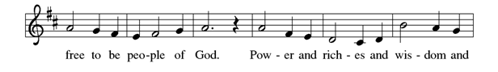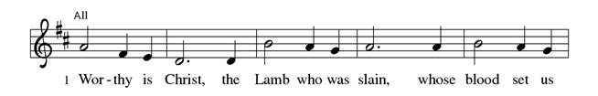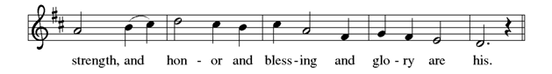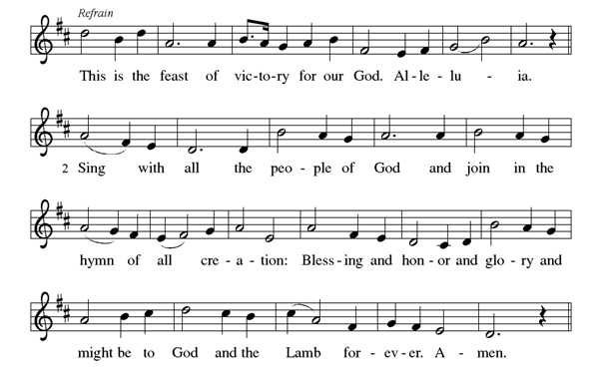

P: The Lord be with you. And also with you.

-4-
P: Let us pray. Lord God,
C: with endless mercy you receive the prayers of all who call
upon you. By your Spirit show us the things we ought to do,
and give us the grace and power to do them, through Jesus
Christ, our Savior and Lord. Amen.
WORD

First Reading Isaiah 58:1-9a

Shout out, do not hold back! Lift up your voice like a trumpet! Announce to my people their rebellion, to the house of Jacob their sins. ²Yet day after day they seek me and delight to know my ways, as if they were a nation that practiced righteousness and did not forsake the ordinance of their God; they ask of me righteous judgments, they delight to draw near to God. ³“Why do we fast, but you do not see? Why humble ourselves, but you do not notice?” Look, you serve your own interest on your fast day, and oppress all your workers. ⁴Look, you fast only to quarrel and to fight and to strike with a wicked fist. Such fasting as you do today will not make your voice heard on high. Is such the fast that I choose, a day to humble oneself? Is it to bow down the head like a bulrush, and to lie in sackcloth and ashes? Will you call this a fast, a day acceptable to the Lord? ⁶Is not this the fast that I choose: to loose the bonds of injustice, to undo the thongs of the yoke, to let the oppressed go free, and to break every yoke? ⁷Is it not to share your bread with the hungry, and bring the homeless poor into your house; when you see the naked, to cover them, and not to hide yourself from your own kin? ⁸Then your light shall break forth like the dawn, and your healing shall spring up quickly; your vindicator shall go before you, the glory of the Lord shall be your rear guard. ^{9a}Then you shall call, and the Lord will answer; you shall cry for help, and he will say, Here I am.
L: Word of God, Word of life.
C: Thanks be to God.

Responsive Reading Psalm 112:1-10

L: Hallelujah! Happy are they who fear the Lord and have great

delight in God’s commandments!

C: Their descendants will be mighty in the land; the generation

of the upright will be blessed.

L: Wealth and riches will be in their house, and their

righteousness will last forever.

C: Light shines in the darkness for the upright; the righteous are

merciful and full of compassion.

L: It is good for them to be generous in lending and to manage

their affairs with justice.

C: For they will never be shaken; the righteous will be kept in

everlasting remembrance.

L: They will not be afraid of any evil rumors; their heart is

steadfast, trusting in the Lord.

C: Their heart is established and will not shrink, until they see

their desire upon their enemies.

L: They have given freely to the poor, and their righteousness

stands fast forever; they will hold up their head with honor.

C: The wicked will see it and be angry; they will gnash their

teeth and pine away; the desires of the wicked will perish.

Second Reading 1 Corinthians 2:1-12
When I came to you, brothers and sisters, I did not come proclaiming the mystery of God to you in lofty words or wisdom. ²For I decided to know nothing among you except Jesus Christ, and him crucified. ³And I came to you in weakness and in fear and in much trembling. ⁴My speech and my proclamation were not with plausible words of wisdom, but with a demonstration of the Spirit and of power, ⁵so that your faith might rest not on human wisdom but on the power of God. ⁶Yet among the mature we do speak wisdom, though it is not a wisdom of this age or of the rulers of this age, who are doomed to perish. ⁷But we speak God’s wisdom, secret and hidden, which God decreed before the ages for our glory. ⁸None of the rulers of this age understood this; for if they had, they would not have crucified the Lord of glory. ⁹But, as it is written, ”What no eye has seen, nor ear heard, nor the human heart conceived, what God has prepared for those who love him”— ¹⁰these things God has revealed to us through the Spirit; for the Spirit searches everything, even the depths of God. ¹¹For what human being knows what is truly human except the human spirit that is within? So also no one comprehends what is truly
-6-
God’s except the Spirit of God. ¹²Now we have received not the spirit of the world, but the Spirit that is from God, so that we may understand the gifts bestowed on us by God.

L: Word of God, Word of life.
C: Thanks be to God.
Stand
Gospel Acclamation Page 151
P: The Holy Gospel according to St. Matthew, the fifth chapter.
C: Glory to you, O Lord.

Gospel Reading Matthew 5:13-20
Jesus said: “You are the salt of the earth; but if salt has lost its taste, how can its saltiness be restored? It is no longer good for anything, but is thrown out and trampled under foot. ¹⁴“You are the light of the world. A city built on a hill cannot be hid. ¹⁵No one after lighting a
lamp puts it under the bushel basket, but on the lampstand, and it gives light to all in the house. ¹⁶In the same way, let your light shine before others, so that they may see your good works and give glory to your Father in heaven. ¹⁷“Do not think that I have come to abolish the law or the prophets; I have come not to abolish but to fulfill. ¹⁸For truly I tell you, until heaven and earth pass away, not one letter, not one stroke of a letter, will pass from the law until all is accomplished.
¹⁹Therefore, whoever breaks one of the least of these commandments, and teaches others to do the same, will be called least in the kingdom of heaven; but whoever does them and teaches them will be called great in the kingdom of heaven. ²⁰For I tell you, unless your righteousness exceeds that of the scribes and Pharisees, you will never enter the kingdom of heaven.”

P: The Gospel of the Lord.
C: Praise to you, O Christ!
Sit
Children’s Message Pam Ensley
Message Pr. Chris Hogstad
Hymn of the Day “Lord, Whose Love in Humble Service" Number 712
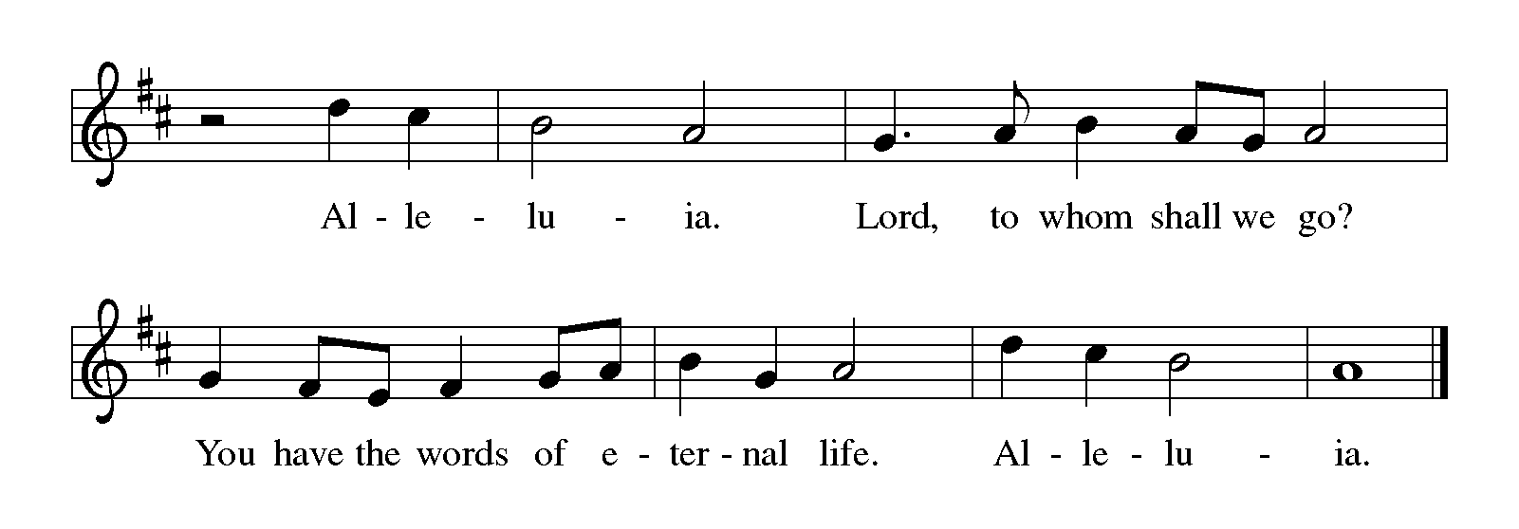1. Lord, whose love in humble service bore the weight of human
need, who upon the cross, forsaken, worked your mercy’s
perfect deed: we, your servants, bring the worship not of voice
alone, but heart; consecrating to your purpose ev’ry gift which
you impart.
2. Still your children wander homeless; still the hungry cry for
bread; still the captives long for freedom; still in grief we mourn
our dead. As you, Lord, in deep compassion healed the sick and
freed the soul, by your Spirit send your power to our world to
make it whole.
3. As we worship, grant us vision, till your love’s revealing light in its
height and depth and greatness dawns upon our quickened sight,
making known the needs and burdens your compassion bids us
bear, stirring us to ardent service, your abundant life to share.
4 Called by worship to your service, forth in your dear name we go,
to the child, the youth, the aged, love in living deeds to show;
hope and health, good will and comfort, counsel, aid and peace
we give, that your servants, Lord, in freedom may your mercy
know and live.
Apostles’ Creed
I believe in God, the Father almighty, creator of heaven and
earth.
I believe in Jesus Christ, God’s only Son, our Lord, who was
conceived by the Holy Spirit, born of the virgin Mary, suffered
under Pontius Pilate, was crucified, died, and was buried; he
descended to the dead. On the third day he rose again; he
ascended into heaven, he is seated at the right hand of the
Father, and he will come to judge the living and the dead.
-8-
I believe in the Holy Spirit, the holy catholic church, the
communion of saints, the forgiveness of sins, the resurrection of
the body, and the life everlasting. Amen.
The Prayers
Called together to follow Jesus, we pray for the church, the world, and all in need.
A brief silence
Call your people to seek your wisdom in difficult conversations and
action. Give the church everywhere courage to repent for the ways
we have tolerated and practiced injustice. Merciful God, receive our
prayer.
Inspire our wonder at creation, from the light of dawn to the beauty
of the dark night. Sustain the unseen depths of the ocean to the
plants and animals we know well. Bring healing to lands and
communities experiencing natural disasters. Merciful God, receive our
prayer.
Instruct the powerful in your ways. Provide upright leadership in
business and industry, that workers are not oppressed. Throughout
the world, inspire voters and raise up politicians to heed your call for
nations to practice righteousness. Merciful God, receive our prayer.
Loosen the bonds of injustice in our midst. Grant peace to endless
quarrels, put an end to hunger, and break every yoke of oppression.
Shelter all who flee abuse in their homes or violence in their
communities. Satisfy those afflicted in any way, especially those we
remember aloud or in our hearts. Merciful God, receive our prayer.
Shape our congregation to be salt for the earth. Give us delight in your
commandments, that we are generous with those in need. Make us
steadfast in our trust in you, ready with tangible mercy and
compassion for our neighbors. Merciful God, receive our prayer.
The cross and resurrection bring redemption from sin and death. We
praise you for all whose unshaken faith in Christ shines forth in their
witness. Keep them in our remembrance and bring us with them into
the kingdom of heaven. Merciful God, receive our prayer.
We bring to you our needs and hopes, O God, trusting your wisdom
and power revealed in Christ crucified. Amen.
-10-
Peace
P: The peace of the Risen Christ be with you always. And also with
you.
Offering of Tithes and Gifts
Offertory “Eye Has Not Seen” Marty Haugen
Prayer of Preparation
P: Liberating God,
C: you break the bonds of injustice and let the oppressed go free.
Receive these offerings in thanksgiving for all your works of
merciful power, and shape us as people of your justice and
freedom. You we magnify and adore, through Jesus our Savior.
Amen.
MEAL
Great Thanksgiving Page 152

Preface
Holy, Holy, Holy Page 152

Eucharistic Prayer
The Lord’s Prayer
Our Father, who art in heaven, hallowed be thy name, thy kingdom come, thy will be done, on earth as it is in heaven. Give us this day our daily bread; and forgive us our trespasses, as we forgive those who trespass against us; and lead us not into temptation, but deliver
us from evil. For thine is the kingdom, and the power, and the glory,
forever and ever. Amen.
Invitation to Communion
P: Come and taste the joy of God!
Distribution Hymns
“As the Grains” Number 465
Refrain:
As the grains of wheat once scattered on the hill were gathered
into one to become our bread; so may all your people from all
the ends of earth be gathered into one in you.
1. As this cup of blessing is shared within our midst, may we
share the presence of your love. Refrain
2. Let this be a foretaste of all that is to come when all creation
shares this feast with you. Refrain
“This Little Light of Mine” Number 677
1 This little light of mine, I'm goin'-a let it shine; this little light of
mine, I'm goin'-a let it shine; this little light of mine, I'm goin'-a let
it shine, let it shine, let it shine, let it shine.
2 Ev'rywhere I go, I'm goin'-a let it shine; ev'rywhere I go, I'm goin'-a
let it shine; ev'rywhere I go, I'm goin'-a let it shine, let it shine, let
it shine, let it shine.
3 Jesus gave it to me, I'm goin'-a let it shine; Jesus gave it to me, I'm
goin'-a let it shine; Jesus gave it to me, I'm goin'-a let it shine, let it
shine, let it shine, let it shine.
Blessing
P: May the grace of our Lord Jesus Christ and the gifts of his body
and blood strengthen, keep and unite us both now and forever.
Amen.

Prayer after Communion
Holy One, we thank you for the healing that springs forth abundantly
from this table. Renew our strength to do justice, love kindness, and
journey humbly with you. Amen.
Benediction
P: The God who faithfully brings forth justice and breaks the
oppressor’s rod ☩ bless, strengthen, and uphold you, today
and always. Amen.
Sending Hymn "Sent Forth by God's Blessing" Number 547
1. Sent forth by God's blessing, our true faith confessing, the people
of God from this dwelling take leave. The supper is ended. Oh, now
be extended the fruits of this service in all who believe. The seed of
Christ’s teaching, receptive souls reaching, shall blossom in action
for God and for all. Your grace shall incite us, your love shall unite
us to work for your kingdom and answer your call.
2. With praise and thanksgiving to God ever living, the tasks of our
ev'ryday life we will face -- our faith ever sharing, in love ever
caring, embracing God’s children, the whole human race. With
your feast you feed us, with your light now lead us, unite us as ne
in this life that we share. Then may all the living with praise and
thanksgiving give honor to Christ and his name that we bear.

Dismissal

P: Go in peace. Follow the way of Jesus. Thanks be to God!
Postlude
Today’s Flowers – Mike & Ruth Ladage
Thanks be to God for the many blessings of 49 years of marriage!
Coffee Hour – Council
-12-
SERVICE
Usher Norm Bembenek
Greeter Florence Faraone
Lector Nancy Bibler
Sound Tech Matt Sitler
Digital Media Coordinator Angelyka Cava
Musicians Pat Hagensen, Gary Ritter, Judy Swanson
Lay Assistant, Basket Assistant Megan Hogstad, Taylor Hogstad
Altar Guild Karen Blair, Arlys Borjesson, Tiffany Ladage

Liturgy used with permission under license from Augsburg Fortress
through Sundays and Seasons,#SAS006227; Text, Music, and
Streaming - One License #A-706949; CCLI #791428
“God, Whose Almighty Word”
Text: John Marriot
Music: ITALIAN HYMN, Felice de Giardini
“Lord, Whose Love in Humble Service"
Text: Albert F. Bayly
Music: BEACH SPRING; The Sacred Harp, arr. Selected Hymns, 1985
Text @ Oxford University Press; words OneLicense #53911
Arr. @ 1985 Augsburg Fortress; music OneLicense #10266
“Eye Has Not Seen”
Text: Refrain based on 1 Corinthians 2:9-10, Marty Haugen
Music: Marty Haugen
Text and music @1982, 1983 GIA Publications, Inc.
“As the Grains”
Text: Didache, 2nd century; Marty Haugen
Music: AS THE GRAINS, Marty Haugen
Text and music @1990 GIA Publications, Inc.
“This Little Light of Mine”
Text: African American spiritual
Music: African American spiritual; arr. Horace Clarence Boyer
Arr. @ Horace Clarence Boyer
"Sent Forth by God's Blessing"
Text: Omer Westendorf
Music: THE ASH GROVE, Welsh folk tune
Text @1964 World Library Publications

